Contents

1.1 Process Overview 2

1.2 Matching 3

1.3 Report Overview 3

1.3.1 Weight Summary 4

1.3.2 Log Summary 4

1.3.3 Matching Summary 5

1.3.4 Matching Detail 5

1.4 Process Schedule 6

1.4.1 Initial Data Submission 6

1.4.2 Integration Review 7

1.4.3 Production Run 8

1.5 Timeline for Data Integration 9

1.5.1 Transition 9

1.5.2 Conversion 10

## Process Overview

Data Integration is the process of combining the parish data with existing information in the ParishSOFT Diocesan central database for the same parish organization ID.  The goal of the process is to limit the number of duplicate families introduced into the ParishSOFT database when bringing a new parish into the system. To accomplish this, we have configured a set of matching logic to identify families that are in both the parish data and the ParishSOFT diocesan database.  We use the following standard weights listed below for each field:

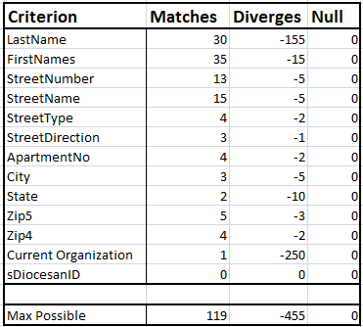

**Non-Matched Family Options:**

The Diocese has two options for non-matched family records.

1. Have the non-matched family records moved to a holding* tank organization. We recommend the use of our standard organization of: Sync Project Non-Matched Families, which will be automatically generated by ParishSOFT.
2. Leave the non-matched family records in the parish organization.

## Matching

We will match the families in the Parish data with the Diocesan data, based on the criteria above. Following the completion of the data integration, you will receive a report of which families were matched and those that were not (more details on this in the Reports section below). For each family that is matched between the parish and diocesan data, the following will take place:

* All Family and Member information in the diocesan database will be replaced with all the parish data, including, parish Offering, Ministry Scheduler and Religious Education data.
  + Except:
    - Diocesan Family DUIDs
    - Diocesan Pledges/Contributions

Will be retained from the diocesan record.

* Members with an assignment in the Diocesan database will have their assignment removed if matched to a parish member. This assignment will need to be re added once the integration is complete.

**Ineligible for Matching**

* If a family is mapped to any other parish in the Diocesan data the Family will be ineligible for matching. These family records will be left in the parish/organization view. Following your data integration production run any of these families that you deemed a match may be merged by the diocese.

## Report Overview

As a part of the Data Integration Process you will receive a report file.  These reports are provided in Microsoft Excel and contain specific information regarding the process on each tab.  Detail on each report is included below.

### Weight Summary

This report provides a summary of the field weights applied in the matching process.  This directly impacts whether or not families are determined to match and are merged during integration.

### Log Summary

On this report, you can find a list of the counts at various stages of the process.  Each of the fields on the report is described below:

* **Source Family Count:** This is the number of families in the parish data prior to running the Data Integration Process.
* **Families Matched:** This is the number of families in the parish data where a match was identified in the diocesan data.
* **Families Moved:** This number corresponds to the number of families in the diocesan data NOT matched to the parish data. These families have been moved to the holding* tank organization with a Registration Status of Registered and a Family Group of Inactive, for manual review at the end of the process. If they are deemed to be relevant to the parish, the parish can re-add them to their organization following integration.
* **Families Inserted:** This is the number of families we did not find a match for so they have been inserted into the ParishSOFT diocesan database from the parish data.
* **Retained:** Same as “Families Matched”.
* **Moved:** Same as “Families Moved”. It is the number of families moved to the holding* tank organization for manual review following the integration process. These families will **not** show in the parish data in ParishSOFT but will only appear in the holding* tank organization following the integration process.
* **Original AIM Count:** This is the number of families in the diocesan database marked assourced by the parish organization ID before the integration process began.

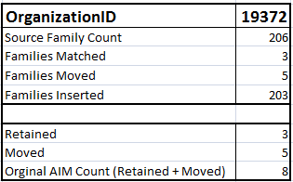

### Matching Summary

This report groups the common combinations of fields for “Matches On”, “Diverges On”, and “Null On”. The number of families in each of these combinations is summarized in the “Match Count” column. This provides insight at an aggregate level. More detail is provided in the Matching Detail report described below.

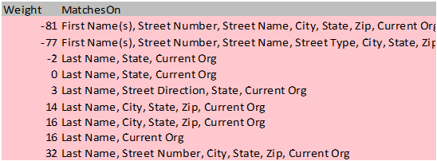

### Matching Detail

This lists every single family in the parish source data deemed as having a potential match in the diocesan data base. These potential matches are then assigned a Weight value. Our standard cutoff for this weight value is 70. Any record listed below the weight threshold of 70 would be considered a non-match and will be added as a new family to ParishSOFT.

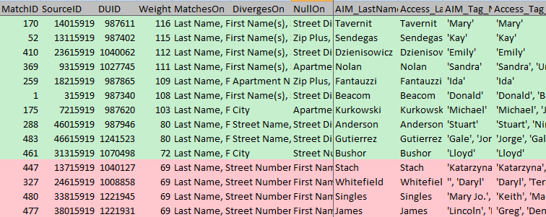

*\*The diocese has two options for non-matched family records. 1) Move the records to a holding tank organization. 2) Leave the non-matched family records in the parish organization.*

## Process Schedule

Once the decision has been made to move to ParishSOFT we will assist you in selecting a date to complete this process. Note: If the move to ParishSOFT is a part of an Arch/Diocesan group rollout, the schedule will be coordinated between the Arch/Diocese and the ParishSOFT project manager and communicated to the parish by the Arch/Diocese. The parish should get started on any data cleanup steps required prior to the integration once they have been scheduled.

### Initial Data Submission

**If the parish is coming from ParishSOFT Desktop:**

Once the transition date arrives, follow the instructions provided by our Implementation team to backup the ParishSOFT desktop database. If the parish encounters issues with their backup, please contact our Customer Success team at 866-930-4774 ext. 2 for assistance. For those we host on Remote Solutions, ParishSOFT will pull their data on the scheduled date.

After the parish submits their backup to ParishSOFT, they may continue updating data in their current system throughout the integration review period.

**If the parish is converting from another software source:**

They will complete a conversion checklist and receive an FTP site to use for data submission. They should upload their data to this site by the end of business, the day before, their scheduled conversion date. **Once the backup is submitted the parish must stop using their current** **system.** Any changes made after this point in the current system **WILL NOT** be brought into ParishSOFT Family Suite.

### Integration Review

**If the parish is coming from ParishSOFT Desktop:**

During the review period, we will integrate the parish data with the diocesan data and then provide the parish and Arch/Diocese with a login to a temporary ParishSOFT site to review the integrated data. You will receive the previously mentioned reports documenting what happened in the integration process to assist in your review. While we complete intensive internal data quality checks throughout the integration process, it is important to verify the information is correct in the interface from both the parish and diocesan perspectives.  Once the parish and the Arch/Diocese have validated the data is correct, both will submit a data integration approval to ParishSOFT and the production integration will be scheduled.

**If the parish is converting from another software source:**

We will use the conversion checklist submitted by the parish to validate and convert the parish data. When the conversion is completed the parish will receive a login to a temporary ParishSOFT site to review the parish converted data. The parish will receive a conversion report to assist in their conversion review. While we complete intensive internal data checks throughout the conversion process, it is important to verify the information is correct in the interface from the parish perspective. Once the parish has validated the converted data is accurate, they will submit a conversion signoff to ParishSOFT so the process can move to the next step and the data integration review will be scheduled.

During the data integration review process, we will integrate the parish data with the ParishSOFT diocesan data and provide both the parish and Arch/Diocese with a login to a temporary ParishSOFT site to review the data integration. You will receive the previously mentioned reports documenting what happened in the integration process to assist in your review. While we complete intensive internal data checks throughout the integration process, it is important to verify the information is correct in the interface from both the parish and diocesan perspectives.  Once the parish and Arch/Diocese have validated the data is correct, both will submit a data approval to ParishSOFT and the production integration will be scheduled.

### Production Run

**If the parish is coming from ParishSOFT Desktop:**

On the morning of the scheduled production run, the parish should follow the backup instructions provided by the ParishSOFT Implementation team to submit the latest copy of their desktop database. At this point, it is important that the parish **STOP** using their current database while we move the data into ParishSOFT Family Suite. If they experience issues backing up their desktop software, please call 866-930-4774 ex 262 for assistance.

Once the parish data has been loaded into ParishSOFT the parish will receive login credentials. At this point the parish is live in the system. We recommend the parish and arch/diocese complete one final review of the data.

**If the parish is converting from another software source:**

We will use the **original** backup supplied for the conversion into ParishSOFT Family Suite. Once the parish data has been loaded into ParishSOFT the parish will receive login credentials. At this point the parish is live in the system. We recommend the parish and arch/diocese complete one final review of the data.

At this point the Arch/Diocese may supply the parish with the list of non-matched families for review.

## Timeline for Data Integration

### Transition

|  |  |
| --- | --- |
| **Desktop Transition/Integration Timeline** | **Business Days to Complete** |
| Parish submits backup and continues to work in their desktop data. | 1 |
| ParishSOFT completes the data integration and provides both the parish and Arch/Diocese with a login to a staging site for review. | 3 |
| Parish and Arch/Diocese reviews integrated data in a staging site and if there are data discrepancies reports them to ParishSOFT Implementations. | 2-5 |
| In the event there are data discrepancies, the ParishSOFT data team will provide a response about the discrepancies within 2-3 business days.  Depending on the severity of the issue it may take longer than that to resolve the issue; however, the team will assess the issue and respond within the 2-3 business days. | Variable |
| Parish and Arch/Diocese signs-off on the Data Integration review data | 1 |
| Parish submits a fresh backup and the Parish stops working in the desktop database. ParishSOFT completes Data Integration into production and provides parish full access. This process takes 3 business days from your scheduled start date | 3-5 |
| Total Estimated Integration Time | 15 |

|  |  |
| --- | --- |
| **Data Conversion/Integration Timeline** | **Business Days to Complete** |
| Parish completes Conversion Checklist, submits backup and stops working in their current data. | 2 |
| ParishSOFT completes data conversion and provides parish with staging site for review. | 10 |
| Parish reviews converted data in a staging site and if there are data discrepancies reports them to ParishSOFT Implementations. | 2-5 |
| In the event there are data discrepancies, the ParishSOFT data team will provide a response about the discrepancies within 2-3 business days.  Depending on the severity of the issue it may take longer than that to resolve the issue; however, the team will assess the issue and respond within the 2-3 business days. | Variable |
| Parish Signs-Off on converted data | 1 |
| ParishSOFT Integrates data into a new staging site and provides both the parish and arch/diocese with logins to review. | 3 |
| Parish & Diocese review and sign-off on Integrated data in Staging site. | 2-5 |
| ParishSOFT completes Data Integration into production and provides parish full access This final process takes 3 business days from your scheduled start date | 3-5 |
| Total Estimated Integration Time | 30 |

### Conversion