**How to Remove the Apostrophe in Excel**

When exporting a leading zero from another program, an apostrophe is added in front in Excel. If the apostrophe is removed with find and replace, the leading zero is dropped. This creates the dilemma of having 4 digits zipcodes or zipcodes with an apostrophe in them. Here is the solution:

1. Select Postal code column to highlight it and Click Find & Select button.

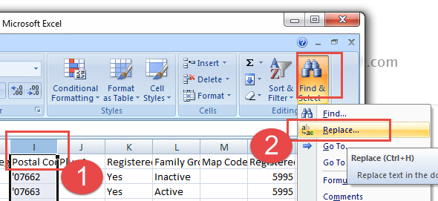

1. Find What is an apostrophe. Replace with is nothing (not even a space). Select **Replace All.**

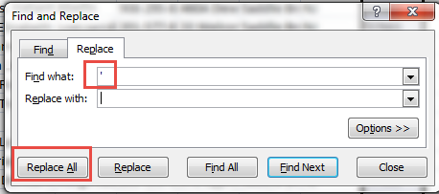

1. Now you should see 4 digit postal codes for any that had leading zeros.
2. Right click on the postal code column and select Format Cells…

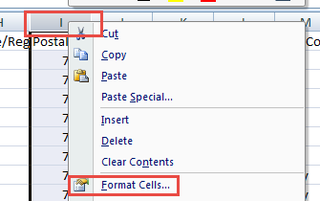

1. Select Custom and Highlight 0. We are almost done.

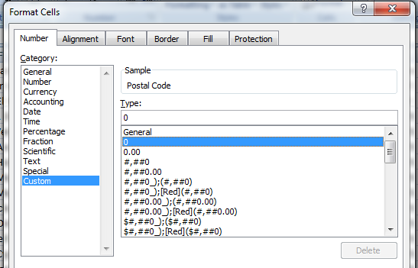

1. Now directly under Type, enter five zeros (these are placeholders for the values, which will bring back the zeros). Then click OK.

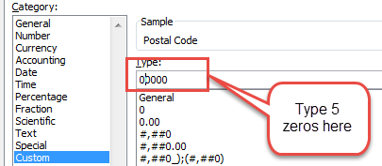

1. Your Excel spreadsheet now has the postal codes with leading zeros and without apostrophes.